Welcome to Ystwyth Medical Group

You will need to upload a digital picture of your signature to these forms.
You can do this by saving a picture of your signature and then adding the picture to the form.

Once you have completed these forms, please email them to contact.w92025@wales.nhs.uk

- We may have asked you for proof of address. We will contact you if we require proof of address.
- If you are on any repeat medication, we will need to have received your medical history from your previous GP before we can issue more. You can help speed this by sending the white repeat slip in with your registration pack.
- If you are a foreign national, please ensure you complete the date you first came to UK and the GP you have previously registered with. If you are registering with a GP in the UK for the first time you need a valid visa (work, student) and have paid the ‘Immigration Health Surcharge’ (IHS). Please send us a copy of your visa and proof that you have paid the ‘Immigration Health Surcharge’ (IHS).

Please allow up to 2 working days for your registration to be processed.

Thank you.
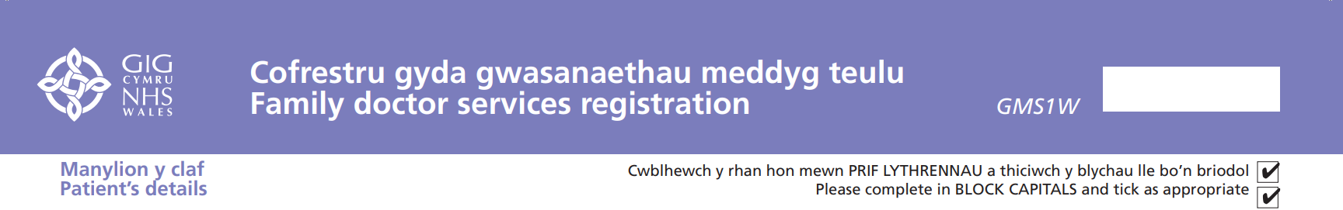
 |  |  |  |  |  |  |  |  |  |  |  |  |  |  |  |  |  |  |  |  |  |  |  |  |  |  |  |  |  |  |  |  | 
 |  |  |  |  |  |  |  |  |  |  |  |  |  |  |  |  |  |  |  |  |  |  |  |  |  |  |  |  |  |  |  |  | 
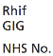 |  |  |  |  |  |  |  |  |  |  |  |  |  |  |  |  |  |  |  |  |  |  |  |  |  |  |  |  |  |  |  |  |  |  |  |  |  |  |  |  |  |  |  |  | 
 |  |  |  |  |  |  |  |  |  |  |  |  |  |  |  |  |  |  |  |  |  |  |  |  |  |  |  |  |  |  |  |  |  |  |  |  |  |  |  |  |  |  |  |  | 

 |  |  |  |  |  |  |  |  |  |  |  |  |  |  |  |  |  |  |  |  |  |  |  |  |  |  |  |  |  |  |  |  | 
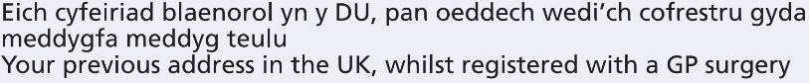
 |  |  |  |  |  |  |  |  |  |  |  |  |  |  |  |  |  |  |  |  |  |  |  |  |  |  |  |  |  |  |  |  |  |  |  |  |  |  |  | 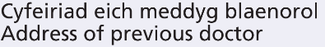

 |  |  |  |  |  |  |  |  |  |  |  |  |  |  |  |  |  |  |  |  |  |  |  |  |  |  |  |  |  |  |  |  |  |  |  |  |  |  |  |  |  |  |  |  |  |  |  |  |  |  | 
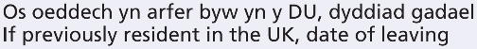 |  |  |  |  |  |  |  |  |  |  |  |  |  |  |  |  |  |  |  |  |  |  |  |  |  |  |  |  |  |  |  |  |  |  |  |  |  |  |  | 
 |  |  |  |  |  |  |  |  |  |  |  |  |  |  |  |  |  |  |  |  |  |  |  |  |  |  |  |  |  |  |  |  |  |  |  |  |  |  |  | 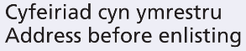
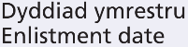 |  |  |  |  |  |  |  |  |  |  |  |  |  |  |  |  |  |  |  |  |  |  | 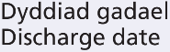 |  |  |  |  |  |  |  |  |  |  |  |  |  |  |  |  | 
 |  |  | 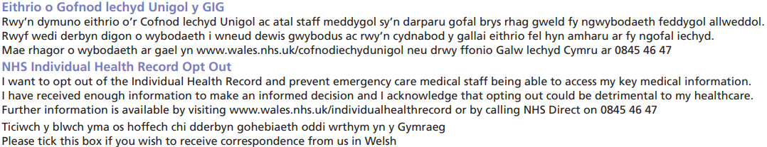
 |  |  |  |  |  |  |  |  |  |  |  |  |  |  |  |  |  |  |  |  |  |  |  |  |  |  |  |  |  |  |  |  |  |  |  |  |  |  |  |  |  | 
 |  |  |  |  |  |  |  |  |  |  |  |  |  |  |  |  |  |  |  |  |  |  |  |  |  |  |  |  |  |  |  |  |  |  |  |  |  |  |  |  |  |  |  |  |  | 
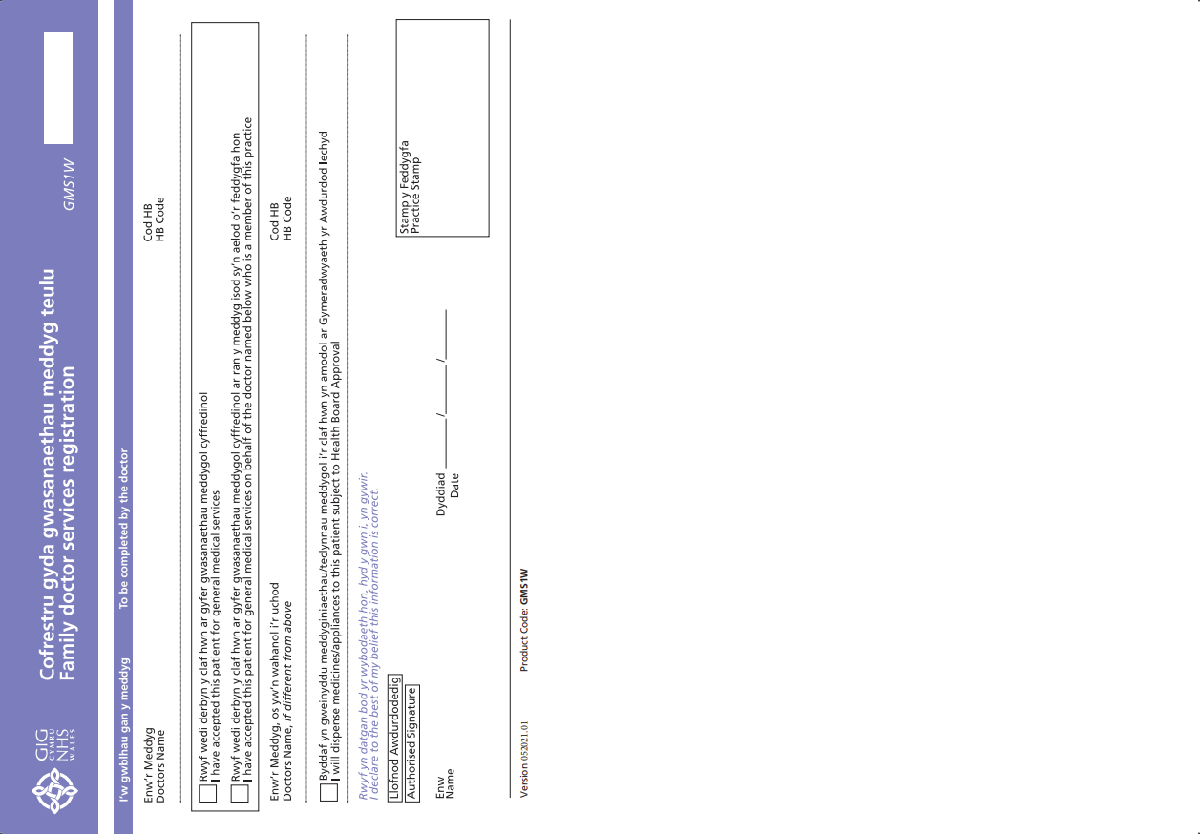

Practice/Patient Contract
At Ystwyth Medical Group, we try to provide optimal care for our patients. This document details how we wish to work together with our patients to provide this. Please read and sign this document.

Opening hours:
We are open from 8 a.m. until 6.30 p.m. Monday to Friday, excluding bank holidays. The Out-of-hours Service can be contacted by ringing 111.

Contact:
It is important that you ensure your contact details are up-to-date at all times. You can update your details via the website or using a form from reception. You can give us permission to contact you with information or reminders via SMS text and also give a third party permission to speak on your behalf and/or collect documents for you.

Appointments: Appointments may be made with the clinicians in advance, but there are some urgent appointments available “on the day”. If you are acutely unwell, we will always try to fit you in, but it may not be with the practitioner of your choice. When you ring, the receptionists will ask you for a brief description of the problem so that they can direct you to the correct clinic.
You may book for specific clinics (e.g. phlebotomy, asthma, diabetes) in advance. There may be a delay in booking routine appointments for some clinics or practitioners when there is a heavy demand.
All the GPs, practitioners and pharmacists provide telephone consultations. Many patients find these more convenient than face-to-face consultation, particularly for follow-up. Please note that, because of workload, we cannot promise to phone at a specific time.
A number of appointments are available via the NHS Wales App, details can be found in your registration pack.
eConsult can be used to request routine advice from the doctor, obtain self help information, or for administrative requests, such as sick notes or letters. The link is on our website.

Cancelling appointments:
Please tell us as soon as possible if you need to cancel an appointment so that another patient can use it.

Late attendance: Please ring us if you are likely to be late so that we can try to accommodate you. If patients arrive late it can mean that the whole clinic runs very late. You may be asked to wait until the end of the clinic or to re-book.

Home visits:
These are only for patients who are housebound and have no possibility of getting to the surgery. Please request before 11.00 a.m. except in emergency. The receptionist will require some basic details of the need for a home visit in order to prioritise it. You may be telephoned by a clinician prior to being visited by a GP or the practice nurse practitioner. We aim to perform all home visits between 12.00 and 15.00.

Test results:
Please ring between 2-4pm and select option 4 ‘Test Results’.

Repeat and acute prescriptions: We are not allowed to take requests for prescriptions over the phone.
Requests can be made using the re-order form and left in the repeat prescribing box at the surgery, via local pharmacies, by post, or via the NHS Wales App.
Repeat prescription requests take 72hrs from a pharmacy. Requests for acute medications may take longer.
You can ring the prescribing clerks if you have any queries by dialling the surgery number and selecting option 2 ‘prescription queries‘.

Prescribing drugs of addiction:
All the local practices are working together to reduce prescribing these medications as required by the Medicines Management Team of the Local Health Board and the Medicines and Healthcare products Regulatory Authority. The medications include diazepam, sleeping pills, opiate painkillers and gabapentinoids. The doctors and pharmacists will discuss with you how we plan to reduce this area of prescribing. We may need to amend your current medications when you register if they do not comply with our prescribing guidelines.

Expected behaviour:
The Practice supports the government's 'Zero Tolerance' policy for NHS Staff. We aim to give optimal care, kindness and consideration to our patients, and our staff have a right to care for others without fear of being attacked or abused. We understand that contacting your GP can at times be stressful and concerning for patients, and will take this into consideration when trying to deal with a misunderstanding or complaint.
However aggressive, abusive or violent behaviour, or any abuse of our services, will not be tolerated under any circumstances. This behaviour may result in you being removed from the Practice list and the Police being contacted. Examples of unacceptable behaviour include;
• Any physical violence
• Verbal abuse in any form including verbal insults, bad language or swearing
• Racial abuse or sexual harassment
• Persistent or unrealistic demands that cause stress to staff will not be accepted. Requests will be met wherever possible and explanations given when they cannot
• Causing damage or stealing
• Obtaining drugs and/or medical services fraudulently

Complaints Procedure:
Should you be dissatisfied with the service we offer; please contact our practice manager Mrs R Copeland to discuss matters. Information about “Putting things right”, our complaints procedure, is available on our website, or from reception.

I have read this contract and agree with the above

Patient signature |  | Date
Practice signature | Dr Grahl, Senior Partner

Consent for someone to collect for you
Consent for someone to speak for you

I consent to the following person(s) collecting the below (please tick as appropriate) on my behalf:

Prescriptions
MED3 forms (sick notes)
Documentation being provided to me by the practice

I consent to the practice speaking with the person(s) named below about:

All my health needs
My medication
My test results
The following specific information (please add clear instructions):

Name | Relationship | Contact Details

Patient signature |  | Date

If you wish to change these instructions, please contact the Practice.

New Patient Questionnaire
This form may assist us to provide good care while we wait for your previous medical records. We may contact you to offer support or advice based on your submission. Thank you for completing this form.

1) | Contacting you |  |  |  |  |  | YES | NO
 | Preferred Language: English / Welsh / Other (Please specify)
 | Email address:
 | Mobile (if aged 16 and over):
 | Do you have any communication/information needs relating to sensory loss and, if so, what are they and how would you like us to communicate with you?
 | We have an electronic method of contact available for patients to contact the surgery for non urgent requests – do you consent for us to correspond with you via this method and supply us with a preferred e-mail address for this purpose?
 | Do you consent to the practice contacting you by text message for appointment reminders, invitations to health checks, vaccination reminders, to let you know that your prescription or your sick note is ready for collection and anything else relevant to your healthcare?
2) | About you |  |  |  |  |  | YES | NO
 | Do you need/have anyone who looks after you or your daily needs as Carer?
 | If Yes, would you like them to deal with your health affairs here?
 | Do you care for anyone else?
 | Are you a family member of someone currently serving in the British Armed Forces?
 | Are you a student at Aberystwyth University?
 | Marital status:
 | Ethnicity:
Asian, Asian Welsh or Asian British  Indian  Pakistani  Bangladeshi  Chinese  Any other Asian background |  |  | Black, Black Welsh, Black British, Caribbean or African  Caribbean  African  Any other Black, Black British or Caribbean background | Mixed or multiple ethnic groups  White and Black Caribbean  White and Black African  White and Asian  Any other Mixed or multiple ethnic background | White Welsh, English, Scottish, Northern Irish or British  Irish  Gypsy or Irish Traveller  Any other White background | Other ethnic group  Arab  Any other ethnic group
 | Details of Next of Kin
 | Name:
 | Contact Number/s:
 | FOR UNDER 12s
 | Parent or Guardian’s full name:
 | Full address and contact number if different to that of the child:
3) | Medications |  |  |  |  |  | YES | NO
If you are issued a prescription, we can send it to a local pharmacy for you to collect.
Please select your one preference for collection;
Borth / Boots Aberystwyth / J.Hoots / Morrisons / Talybont / Well
 | Are you on any repeat medication?
 | If yes please give details:
4) | Past Medical History |  |  |  |  |  | YES | NO
 | Do you / or have you ever had any of the following?
 |  | Cancer
 |  | Heart condition / problem
 |  | Stroke
 |  | Asthma
 |  | Diabetes
 |  | Chronic bronchitis or emphysema
 |  | Epilepsy
 |  | Depression or mental health issues
 |  | Arthritis
 |  | High Blood pressure (Hypertension) on medication
 |  | Low thyroid status (hypothyroidism) on medication
 | Are you currently seeing a hospital consultant?
 |  | If yes please give details:
 | Do you have any allergies?
 |  | If yes please give details:
 | Have you received a blood transfusion prior to 1996?
 |  | If yes please give details:
 | Any other health information:
5) | Family History |  |  |  |  |  | YES | NO
 | Is there any of the following in your family (father, mother, brother, sister) before the age of 65? Please specify which relative
 |  | Heart Disease
 |  | Stroke
 |  | Cancer, if Yes site
6) | Lifestyle |  |  |  |  |  | YES | NO
 | Do you smoke?
 | Do you vape?
 | If you smoke or vape, how many tobacco products per day?
 | Are you an ex smoker? If Yes when did you stop?
 | How many units of alcohol do you drink a week?
 | A standard bottle of wine = 10 units. A 175ml glass =2 units. Single small shot of spirits (25ml) = 1 unit. Pint of 4.5% strength lager/beer/cider = 2.5 units.
 | What is your height?
 | What is your weight?

Immunisation History

 | Date – 1st Dose | Date – 2nd Dose | Date – 3rd Dose | X if given in UK
Tuberculosis (BCG)
Diptheria/tetanus/pertussis/polio/ Hib (5in 1) OR
Diptheria/tetanus/pertussis/polio/ Hib/ Hep B (6 in 1)
Pneumococcal (PCV)
Meningitis B
Measles Mumps Rubella (MMR)
Hib/Men C
Diptheria/Tetanus/pertussis/Polio (pre school booster)
Human papillomavirus (HPV)
Meningococcal ACWY (Men acwy)
Tetanus/ Diptheria /Polio
COVID
Other vaccinations

Any additional information:

Email your completed form to

contact.w92025@wales.nhs.uk

Thank you

